GEORGE STREET

MIDDLE SCHOOL

575 George Street
Fredericton, N.B. E3B 1K2
Tel: (506) 453-5419
Fax: (506) 453-2593
http://georgest.nbed.nb.ca

Principal Vice Principal Vice Principal
Ms. Michelle Ashfield Mrs. Lindsay Edmondson Mr. Jacob Lingley

Dear Parent/Guardian,

George Street Middle School is in the planning stages of a Grade 8 school trip to Quebec city on June 15, 16 and 17, 2026.
This is an educational trip through which students will be exposed to French as well as Canadian & Quebec history and culture.
Points to consider:
To aid us in our efforts to organize this trip, we would like to know the general interest level. In deciding whether your child will participate or not, please note the following:
- The cost of the trip depends on the final number of participants but will cost around $800. There is no GSMS organized fundraiser planned for this.
- The trip will be 3 days and 2 nights (Monday June 15 to Wednesday June 17, 2026).
- A non-refundable deposit of $200 will be made by October 31 to secure a spot on the trip (the final payment will be approx. $600).

Next step

Please complete the section below and send back to school as soon as possible to help us determine a rough number attending. If you have any questions, please contact Richard.beaudry@nbed.nb.ca

Thank you for your support,

Richard Beaudry

YES, I’m planning for my child, ___________________________________, to participate in the trip.

For rooming purpose: gender of my child: Male Female Other

Parent Signature ___________________________

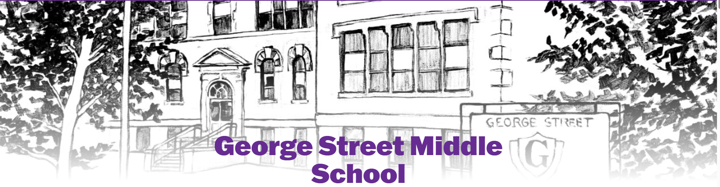________________________________________________________________

Quebec City Trip Agreement

During the trip, I commit to the following:

- I will show respect, follow the expectations, and maintain positive relationships.
- I will not bring or pack anything inappropriate or illegal. A family member will check my bags.
- I am aware that I may be subject to a coat check and/or bag check while on the trip.

I will:

- Be polite = I will show appropriate behaviour and follow directions.
- Be safe = I will always follow the “buddy rule”, making sure that I do not leave the group and travel alone (i.e. shopping, getting food, going to the restroom area, etc.)
- Use my cell phone appropriately = I will limit my cell phone use and focus on interactions with people. My sleep will not be impacted by my cell phone.
- Be respectful of people and property = I will put my trash where it belongs and listen when the guide or chaperone is speaking (no “ear buds”).
- Follow expectations in my room = I will stay in my room during curfew hours and keep the room tidy.

I am aware of the potential consequences if I am unable to follow these expectations:

- I understand that there are consequences if I misbehave.
- I am aware that if I am struggling for social emotional reasons that impact my ability to participate in the trip, my family may be contacted and arrangements for pick up in Quebec may be necessary.
- I am aware that if I am involved in a major infraction (i.e. drinking alcohol, taking drugs, vaping, theft, violence, etc.), my family will be expected to arrange pick up in Quebec.

Agreement
***This signed form must be returned to homeroom teacher by October 31st***

I agree to abide by all the statements listed above during the entire trip.
Student Signature: ______________________________________ Date: ___________________

Parent Signature: _______________________________________ Date: ___________________

